***NAME : Himanshu Dixit***

***ENROLL NO. : B64178***

***BATCH : B10***

***Software Development Fundamentals – I (15B11CI111)***

***ODD 2021***

***Tutorial Sheet – 5***

**Q1.** What will be the output of the C program, if input is **6**?

#include<stdio.h>

int main()

{

int i;

for(i = 0; i>9; i+=3)

{

printf("for ");

}

return 0;

}

**Solution:**

(nothing)

**Q2.** What will be the output of the C program by considering 'b' as a User input?

#include<stdio.h>

int main()

{

for(--i && j++ ; i<10; i+=2)

{

printf("loop ");

}

return 0;

}

**Solution:**

loop loop loop loop loop

**Q3.** What will be the output of the C program?

#include<stdio.h>

int main()

{

for(5;2;2)

printf("Hello");

return 0;

}

**Solution:**

Hello(infinite times)

**Q4.** What will be the output of the C program?

#include<stdio.h>

int main()

{

   int n;

   for (n = 9; n!=0; n--)

     printf("n = %d", n--);

   return 0;

}

**Solution:**

n = 9n = 7n = 5n = 3n = 1n=-1 (so one infinite times)

**Q5.** What will be the output of the C program?

#include <stdio.h>

int main()

{

    int c = 5, no = 10;

    do {

        no /= c;

    } while(c--);

    printf ("%dn", no);

    return 0;

}

**Solution:**

(nothing)

**Q6. Write C programs to print following patterns:**

**(1).**

#include <stdio.h>

int main()

{

int row=10;

//scanf("%d",&row);

for(int i=0; i<row; i++)

{

for(int c=row-1; c>i; c--)

printf(" ");

for(int j=0; j<=i; j++)

printf("* ");

printf("\n");

}

for(int i=0; i<row-1; i++)

{

for(int c=0; c<=i; c++)

printf(" ");

for(int j=row-1; j>i; j--)

printf("* ");

printf("\n");

}

return 0;

}

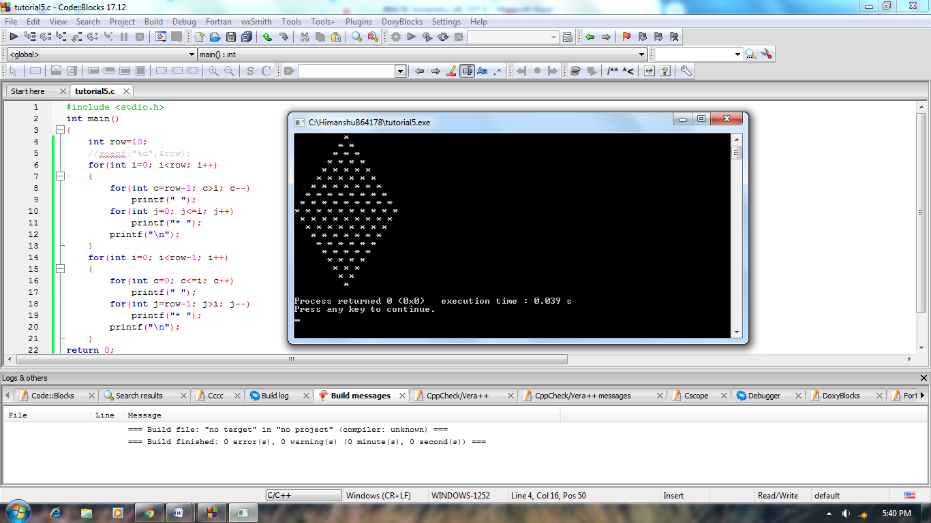

**(2).**

#include <stdio.h>

int main()

{

int row=7;

char a='A';

//scanf("%d",&row);

for(int i=0; i<row; i++)

{

for(int c=row-1; c>i; c--)

printf(" ");

for(int j=0; j<=i; j++)

printf("%c ",a++);

printf("\n");

}

return 0;

}

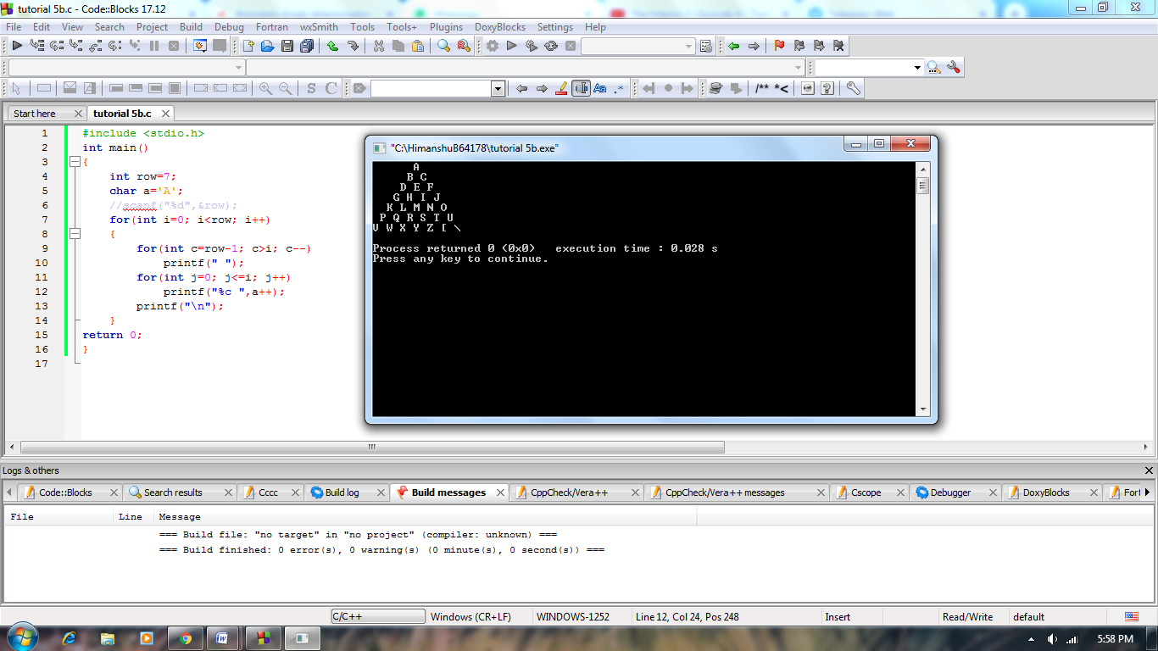

**(3).**

#include <stdio.h>

int main()

{

int row=6;

//scanf("%d",&row);

for(int i=1; i<6; i++)

{

for(int c=row-1; c>i; c--)

printf(" ");

for(int j=1; j<=i; j++)

printf("%d ",i);

printf("\n");

}

return 0;

}

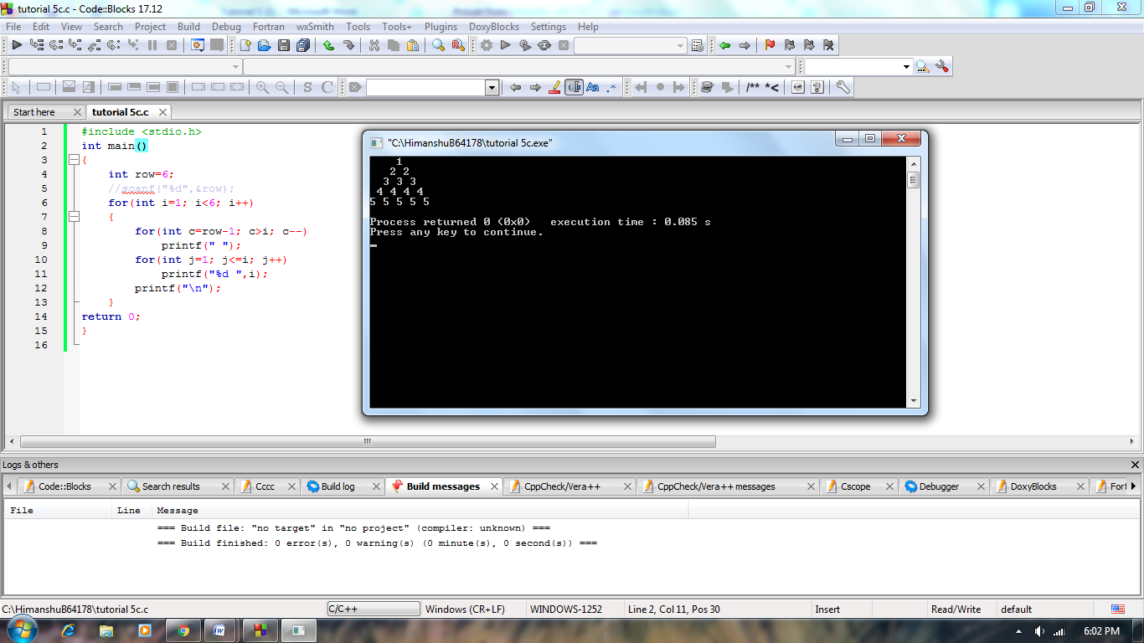

**(4).**

#include <stdio.h>

int main()

{

int row=6;

//scanf("%d",&row);

for(int i=1; i<6; i++)

{

for(int c=row-1; c>i; c--)

printf(" ");

for(int j=1; j<=i; j++)

printf("%d ",j);

printf("\n");

}

return 0;

}

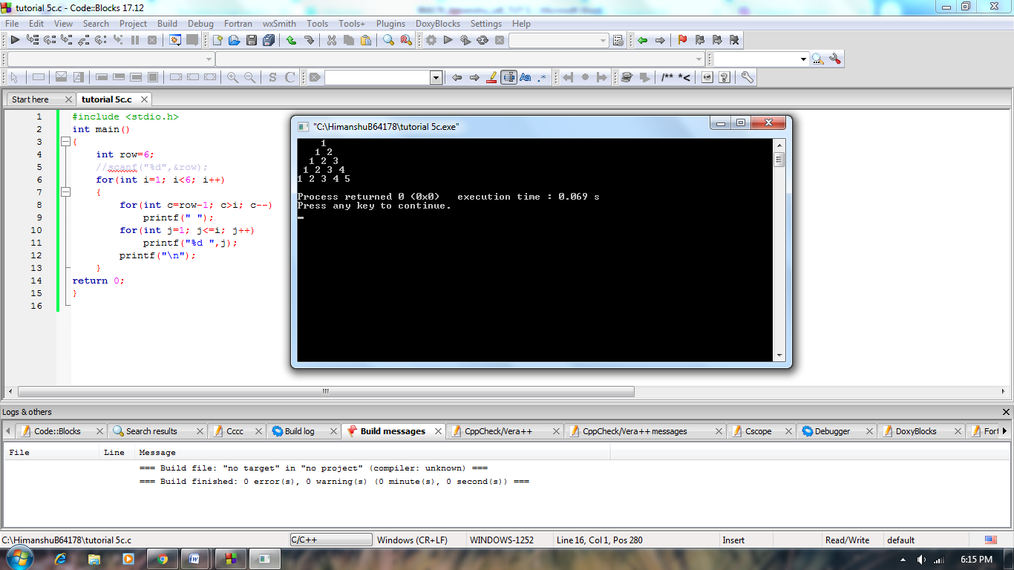

**(5).**

#include <stdio.h>

int main()

{

int row=6,n=1;

//scanf("%d",&row);

for(int i=1; i<6; i++)

{

for(int c=row-1; c>i; c--)

printf(" ");

for(int j=1; j<=i; j++)

printf("%d ",n++);

printf("\n");

}

return 0;

}

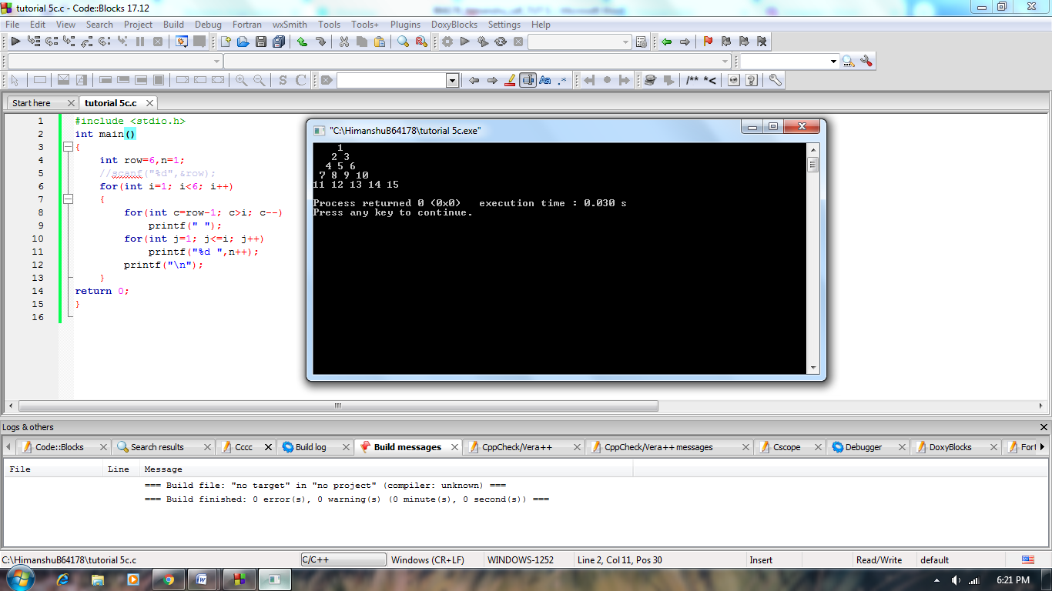

**(6).**

#include <stdio.h>

int main()

{

int row=12,n=1;

//scanf("%d",&row);

for(int i=1; i<=row; i++)

{

n=1;

for(int c=row-1; c>i; c--)

printf(" ");

for(int j=1; j<=i; j++)

{

printf("%d",n*3);

if(i!=j)

printf(", ");

n++;

}

printf("\n");

}

return 0;

}

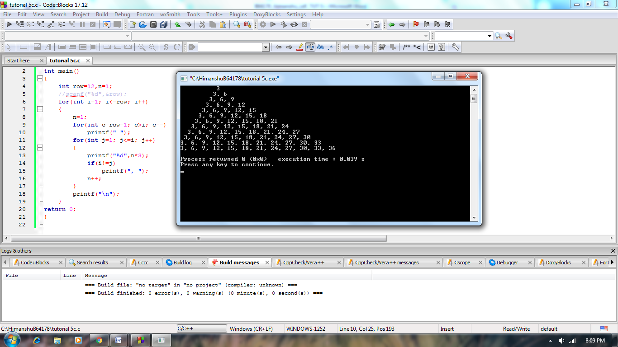

**(7).**

#include <stdio.h>

int main()

{

int row=8,n;

//scanf("%d",&row);

for(int i=1; i<=row; i++)

{

n=i;

for(int c=row; c>i; c--)

printf(" ");

for(int j=1; j<=i; j++)

{

printf("%d",n);

n--;

}

++n;

for(int k=1; k<i; k++)

printf("%d",++n);

printf("\n");

}

return 0;

}

